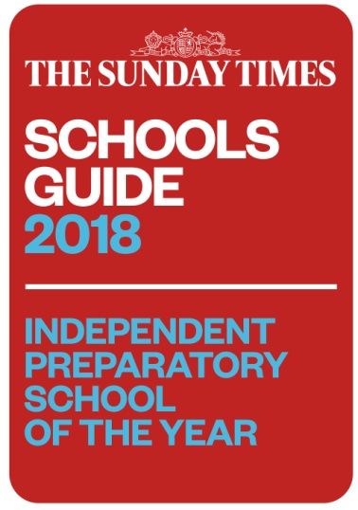
The Sunday Times Independent Prep School of the Year

Notting Hill and Ealing High Junior School GDST

Zoe Thomas
November 19 2017, The Sunday Times

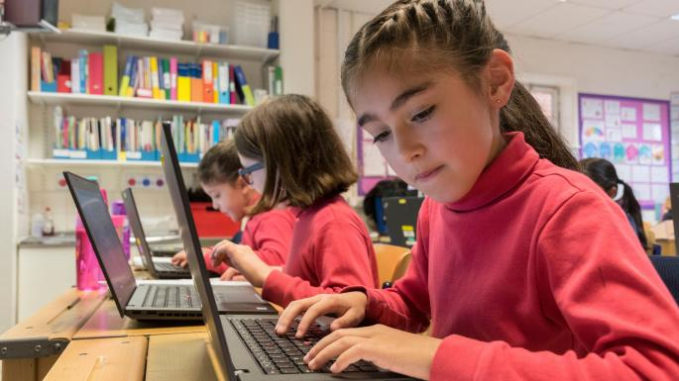

Coding is taught from year 1, and there is specialist teaching for music, PE and science
Photo: JEREMY YOUNG/THE SUNDAY TIMES
Sitting cross-legged on the classroom floor, hair escaping from ponytails and uniform comfortably askew, every child’s upturned gaze is focused on a teacher brandishing a large, cuddly dragon and posing the query: “What would you say to a dragon if you met one?”(Answer: “Ask it to go away.”) The reception class of Notting Hill and Ealing High School Junior School epitomises the down-to-earth charm of this highly successful school.
“This is just the most joyous, happy place,” beams the head, Silvana Silva, who teaches all the four- and five-year-olds in reception once a week herself. It’s a highlight for all concerned that occasionally involves the little ones tethering fairy wings to their indefatigable headmistress.
“I am a passionate believer that the girls have to be happy. And that’s my number one priority,” adds Silva, whose passion for the school started when she joined in 1989 as a class teacher, rising through the ranks to become head in 2013.
Her dedication to stoking pupils’ enthusiasm has also led to her being kidnapped on film as part of a year 2 “turrets and tiaras” combined curriculum project. “They have to write to a knight to come and save them, so it’s really creative, really inspiring,” she explains.
There is method to the imaginative teaching at NHEHS Junior School, as you would expect from The Sunday Times Prep School of the Year 2017, and the belief that happy girls make successful girls underpins everything.
“If they don’t have that joie de vivre, that thirst for learning, that independent research, then they’re not going to excel, they’re not going to do their best,” Silva points out.
And boy, do the girls here do their best. In the key stage 2 Sats last year, NHEHS Junior School’s year 6 pupils scored 115 in reading, 113 in grammar and 110 in maths, smashing the government’s expected standard score of 100 in the new-style scaled results. The school, which ranks joint second with James Allen’s Preparatory School in our league table this year, is a top 10 regular.
“It’s just part and parcel of what we do,” says Silva of her girls’ excellent Sats performance. “It’s so low-key here, they wander in on that Sats week and they do various assessments, and they obviously know what it’s about. But there’s no stressing, there’s no crying. It’s happy, confident girls doing well – that’s the essence.”
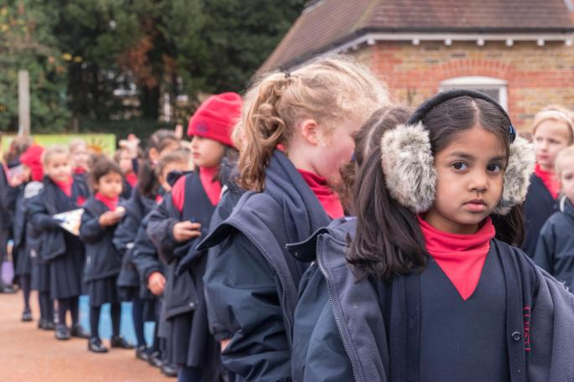
The GDST charges about £1,000 less per term than most other independent day schools PHOTO: JEREMY YOUNG/THE SUNDAY TIMES
Housed in a Victorian villa in a quiet, residential road in Ealing, west London, where the 1873-founded school decamped from Notting Hill in 1930, NHEHS Junior School opens up, Tardis fashion, into a warren of modern classrooms, some in a new extension that backs on to a playground opening out to all-weather sports pitches linking it to the senior school.
As one of 26 schools across Britain that make up the Girls’ Day School Trust (GDST), NHEHS is supported by the network’s staff training courses for all employees, not only the teachers. It also benefits from the trust’s investment programme that has added a swimming pool, large hall and smart dining room at the senior school – all used by the juniors, who trot the short journey past the astroturf pitches to reach them.
The GDST is an “amazing organisation”, Silva enthuses, which “knows about girls’ education”. Another plus for the families forking out for school fees is that the GDST charges about £1,000 less per term than most other independent day schools. At NHEHS Junior School fees are £4,610 per term for 2017-18, with lunch charged at £200 a term on top.
Added to that, “every member of staff runs a club, which is free to parents,” the head says. There are regular offerings such as debating, chess, orchestra, drama and netball clubs, and the girls suggest some more via the school council, such as cake decorating and jewellery.
Most of the girls have two working parents, and wraparound care from 7.30am breakfast club to 6pm after school is there if needed, charged separately. “That’s probably changed quite dramatically over the years that I’ve been here, the majority of mothers work,” remarks Silva.
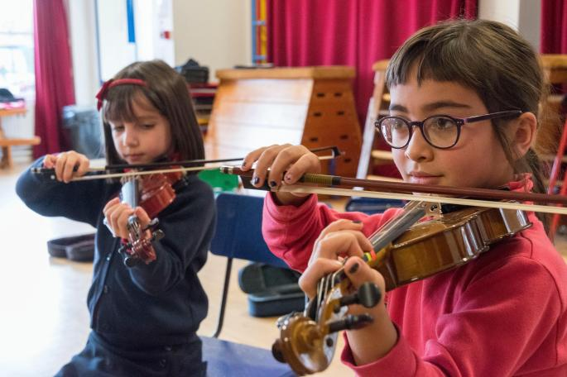

Headteacher Silvana Silva: “This is just the most joyous, happy place”
PHOYO: JEREMY YOUNG/THE SUNDAY TIMES
German and French are taught only in clubs and Mandarin is the sole curricular foreign language from year 1. Coding is also taught from year 1 by the computing teacher, and there is specialist teaching for music, PE (in two timetabled slots each week) and science.
The humanities are taught under an integrated curriculum, well-established at the school. Year groups are given a central hook each term with core texts allied to the teaching, organised around a “stunning start”, a “marvellous middle” and a “fantastic finish”.
Silva references the current year 6’s “memory box” topic, in which the girls enter a room, discover a chest stuffed with artefacts and have to work out whose it might be.
“Spoiler alert: it belongs to a WWI soldier,” she confides. “Their core text is War Game – the story about how Germany and England had a football match on Christmas Day. Interestingly, we got our science teacher involved, and she did an experiment with them about dirty water, because that would have been in the trenches, how you could have filtered it.”
Class teachers cover the majority of subjects all the way up to year 6, “and that’s really important because those teachers really get to know the girls well. They form a bond with them”, says the head, who sings the praises of her “amazing”, “100% committed” staff – support workers and teachers alike.
“And they love it here, and they stay – I have very little staff turnover. They get up early, they stay late, they really, genuinely care about the girls and that comes through all the time,” she enthuses.
When the Independent Schools Inspectorate visited most recently in 2013, inspectors noted many strengths at NHEHS in their report:
• Teaching: “Teachers have an excellent command of their subjects and of the facility to teach; this is a defining feature of the school’s provision.”
• Curriculum: “The curriculum in the junior school is well balanced and meets the needs of the pupils. Lively and imaginative daily learning tasks in the Early Years Foundation Stage (EYFS) capture the children’s attention, inspire them to make informed choices of activities and successfully meet the needs of all.”
• Achievement: “Pupils’ achievements in the junior school including in the EYFS are excellent. They build on their knowledge and skills systematically over time. The pupils in the junior school achieve highly in their linguistic, mathematical and creative learning…”
• Music and sport: [Music is] “exceptional throughout the school with the youngest girls performing with advanced musical confidence”, and “achievement is high” in physical activities and sport, the inspectors reported.
From reception, girls learn to swim in the school pool and as Silva stresses, the all-weather sports pitches “really are used in all weather”. Netball, hockey, dance, gym and athletics are all popular and teams play local and other GDST schools.
With play dates crucial and lengthy commutes undesirable among under-11s, most pupils live nearby, while some travel from Chiswick, Greenford and Harrow. The geographical net widens at year 7 when almost all girls progress to the senior school, where they are joined by an equal number of girls from other schools.
Unconditional offers of places are made to girls in year 5, with very few exceptions – allowing NHEHS Junior School pupils, and their parents, to sidestep the 11+ bunfight for which the London independent school sector is renowned. They still sit the entrance exam, “more for the experience, and also the senior school gets a benchmark of where they are”, Silva notes.

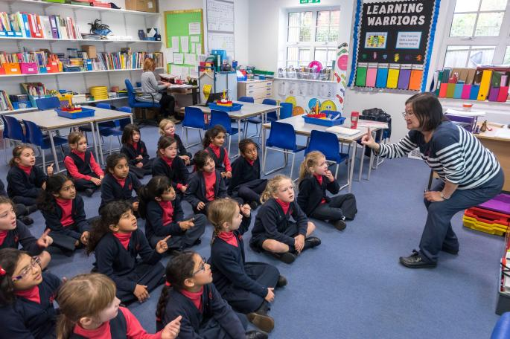

Every member of staff runs a club, which is free to parents
PHOTO: JEREMY YOUNG/THE SUNDAY TIMES
When girls join at 4+, the junior school’s main two-form entry point, it is by play-based assessment, with about 100 applications for 40 places. “They don’t come in writing reams – sometimes it’s scratching at the paper! That’s our job, we bring them on,” says Silva, shutting down any misconceptions about independent schools only taking pupils who can “count to a million, or something”.
Silva reserves her warmest accolades for her “lovely” girls. “They genuinely like their school, love their friends and get on with each other. As a mother I can’t think of anything I would want to have for my own child more than that. They are just happy little beings.”
Reproduced from The Sunday Times 19 November 2017 and also available on line at
https://www.thetimes.co.uk/article/best-uk-schools-guide-independent-preparatory-school-of-the-year-dkpx7ksgs

