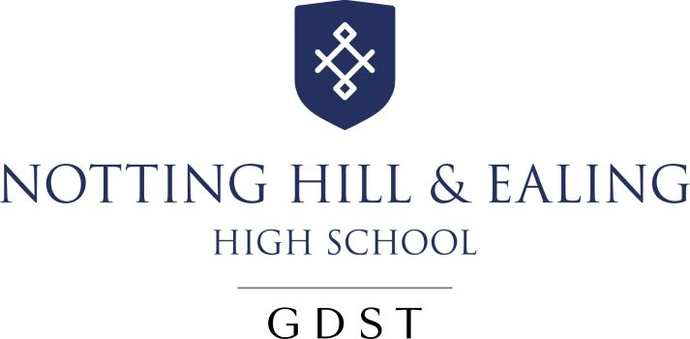 | Notting Hill & Ealing High School  Sixth Form Music Scholarship  Application Form

Name: | Date of birth:  Current School:
Please use this form to tell us what you have accomplished so far in Music and the contribution you have made during your time at school.
Achievements / Awards in Music
In school

Out of school

Involvement in school events / teams / competitions / clubs ... etc

Anything else you would like to tell us (this may include any plans you would like to suggest in support of the Music Department to enhance the life of the school).

Date: _________________________________

